LAWYERS TEAM -2
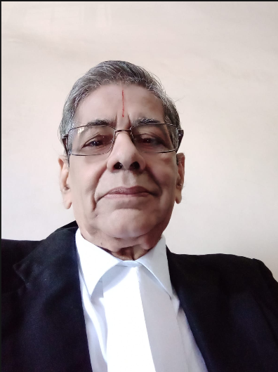

Advocate N. RAMANUJAM
Senior Advocate | Madras High Court
Advocate N. Ramunajam is a Senior Advocate with 55 years of legal experience, practicing since 1970 before the High Court of Judicature at Madras, Chennai. He has extensive expertise across all areas of legal services, including Civil Law, Family Law, and Labour Law. A member of the Chennai Bar Council / Bar Association, he is widely respected for his legal acumen, integrity, and seasoned courtroom advocacy.

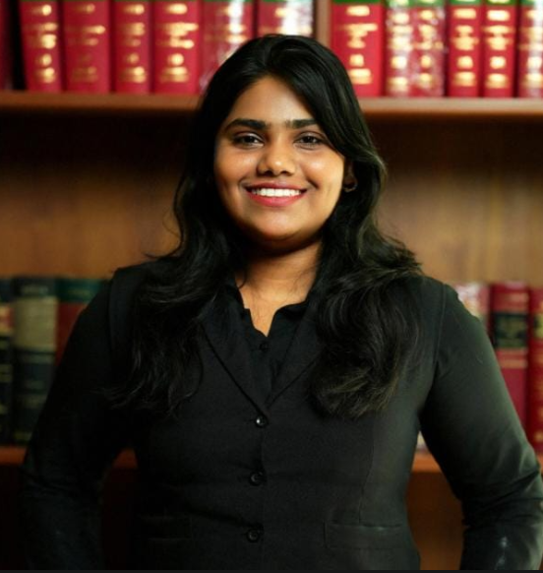

Advocate Janani Kannan, B.Com, LLB.
Advocate Janani Kannan is a Specialist in GST taxation & company law. She has strong expertise in Intellectual Property rights, Corporate Advisory & Compliances, Contracts incl. Deeds , Registrations & Specific Performance, Civil Litigation & Non-Litigation, Commercial Suits & Consumer Cases, Medical Jurisprudence.

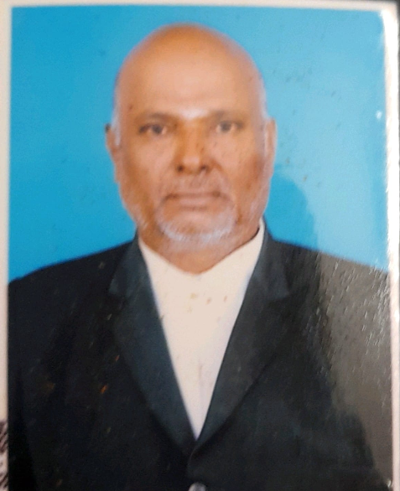

Advocate K.C. Gandhi, B.A., B.L.
Senior Advocate | Madras High Court
Advocate K.C. Gandhi is a Senior Advocate with over 20 years of legal experience, practicing at the District Court of Judicature at Madras, Puducherry. He has strong expertise in Civil Law, Family Law, Finance Law, Company Law, and Motor Accident Claims cases. He is known for his practical legal approach, sound advisory skills, and effective courtroom representation.



Advocate Arbaaz. B.Com, LLB.
Advocate Arbaaz is a Specialist in GST taxation & company law. She has strong expertise in Intellectual Property rights, Corporate Advisory & Compliances, Contracts incl. Deeds , Registrations & Specific Performance, Civil Litigation & Non-Litigation, Commercial Suits & Consumer Cases, Medical Jurisprudence.

